|  |  |
| --- | --- |
| **Project Case** |  |
| COMP6144  Web Programming |
| **Computer Science** | **O202-COMP6144-SO04-00** |
| ***Valid on*** *Odd Semester Year 2020/2021* | **Revision 00** |

1. Seluruh kelompok tidak diperkenankan untuk:

*The whole group is not allowed to:*

* + - Melihat sebagian atau seluruh proyek kelompok lain,

*Seeing a part or the whole project from other groups*

* + - Menyadur sebagian maupun seluruh proyek dari buku,

*Adapted a part or the whole project from the book*

* + - Mendownload sebagian maupun seluruh proyek dari internet,

*Downloading a part or the whole project from the internet,*

* + - Mengerjakan soal yang tidak sesuai dengan tema yang ada di soal proyek,

*Working with another theme which is not in accordance with the existing theme in the matter of the project,*

* + - Melakukan tindakan kecurangan lainnya,

*Committing other dishonest actions,*

* + - Secara sengaja maupun tidak sengaja melakukan segala tindakan kelalaian yang menyebabkan hasil karyanya berhasil dicontek oleh orang lain / kelompok lain.

*Accidentally or intentionally conduct any failure action that cause the results of the project was copied by someone else / other groups.*

1. Jika kelompok terbukti melakukan tindakan seperti yang dijelaskan butir 1 di atas, maka **nilai kelompok** yang melakukan kecurangan (menyontek maupun dicontek) akan di – **NOL** – kan.

*If the group is proved to the actions described in point 1 above, the score of the group which committed dishonest acts (cheating or being cheated) will be “Zero”*

1. Perhatikan jadwal pengumpulan proyek, segala jenis pengumpulan proyek di luar jadwal tidak dilayani.

*Pay attention to the submission schedule for the project, all kinds of submission outside the project schedule will not be accepted*

1. Jangan lupa untuk melihat kriteria penilaian proyek yang ditempel di papan pengumuman, atau tanya asisten anda.

*Don’t forget to look at the project assessment criteria that posted on the announcement board, or ask your teaching assistant.*

1. Persentase penilaiaan untuk matakuliah ini adalah sebagai berikut:

*Marking percentage for this subject is described as follows:*

|  |  |  |
| --- | --- | --- |
| **Tugas Mandiri**  *Assignment* | **Proyek**  *Project* | **UAP**  *Final Exam* |
| - | 100% | - |

1. Software yang digunakan pada matakuliah ini adalah sebagai berikut:

*Software will be used in this subject are described as follows:*

|  |
| --- |
| **Software**  *Software* |
| PHP Composer 1.10.7  PHP Storm 2020.1.2  Visual Studio Code  Laravel Framework 7  XAMPP 7.4.7  Firefox / Chrome |

## Ekstensi file yang harus disertakan dalam pengumpulan tugas mandiri dan proyek untuk matakuliah ini adalah sebagai berikut:

*File extensions should be included in assignment and project collection for this subject are described as follows:*

|  |  |
| --- | --- |
| **Tugas Mandiri**  *Assignment* | **Proyek**  *Project* |
| - | Folder Project (PHP, SQL, Image Files (JPG / PNG), ENV, HTML, CSS, SCSS, JS, JSON, HTACCESS, ARTISAN) |

General Provisions:

* Use **MySQL** asdatabase and must using **Laravel Migration** features.
* **All file upload** feature such as image and document must be **stored to server storage**.
* Use PHP Framework **Laravel 7** to build the project.
* Use Laravel **MVC** concept (**Model, View, Controller**) to build the project.
* Use **Eloquent Query / Query Builder** to work with database.
* You are free to design your own database table **based on given requirements**.
* Print screen given below is only an example. You are free to create your own user interfaces.
* It is **prohibited** to install any kind of Laravel packages. You must use fresh installation of **Laravel 7**.
* Only **validation** in the **backend** (using Laravel) will be graded.

## Soal

*Case*

**$okopedia**

**$okopedia** is a famous Indonesian technology company specializing in e-commerce, to expand its business, **$okopedia** wants to create a website for their shop. In that website, people can find information about the **$okopedia**’s products and order it. This website enables the customers to know what is inside **$okopedia**.

As a web developer, you are asked to create a website using **Laravel** **7** for this online shop. There are three types of user’s role in this website: **Admin**, **Member**, and **Guest** (**non-logged-in user**).

* + - 1. **Login**

This page allows user to log in to the website. Display an **error message** on the login page if user enters wrong combination of **Email** and **Password**.

If user has entered correct **Username** and **Password**, the page will be redirected to the **Home Page** **for customer** or **Admin** based on the user’s role and **if user checks the “Remember Me**” checkbox, the website will save the **Username** and **Password** using cookies for **2 hours**.

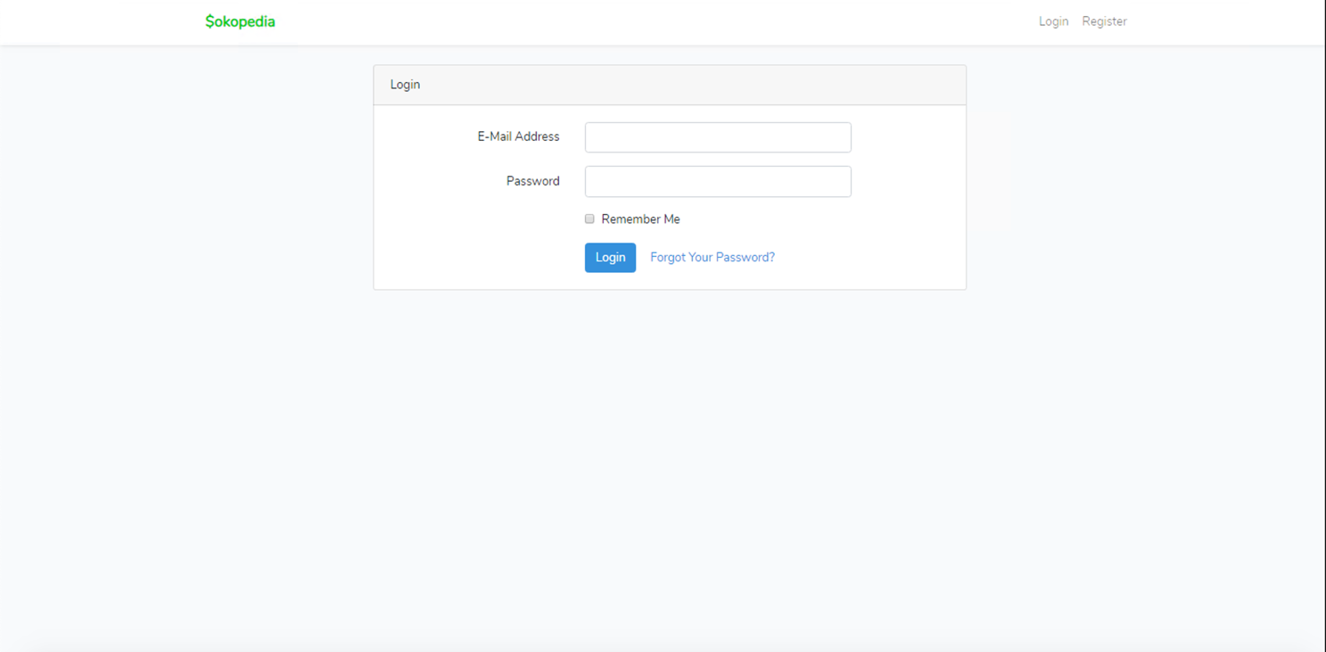

***Figure 1. Login Page***

1. **Register**

This page allows guests to **register** themselves as **$okopedia** member. Display an **error message** if user input incorrect personal data. The following table shows the existing fields on this page and the validation for each field:

|  |  |
| --- | --- |
| **Field** | **Information** |
| **Username** | Must be **filled** |
| **Email Address** | Must be **filled** with **email validation** and **unique** |
| **Password** | Must be **filled** and **minimum 5 characters length** |
| **Confirm Password** | Must be **filled** and **same with password** |

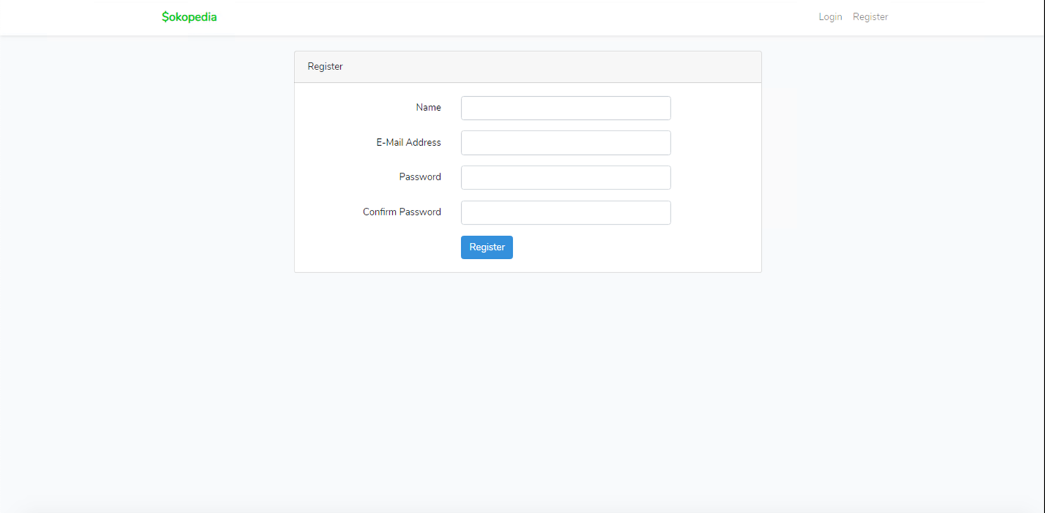

***Figure 2. Register Page***

1. **Home Page**

This page allows user to see all **$okopedia products**. This page is accessible for **all user.** In this page User can also **search by name of product and products paginate by 3.** In this page, guest can **Login** or **Register, this page can be accessed by all users.**

Logged in member will have extra button next to Search button, which is **cart** and **history** and the logged in username. **As for member, each product can be clicked to redirect into “Product’s Detail Page”.**

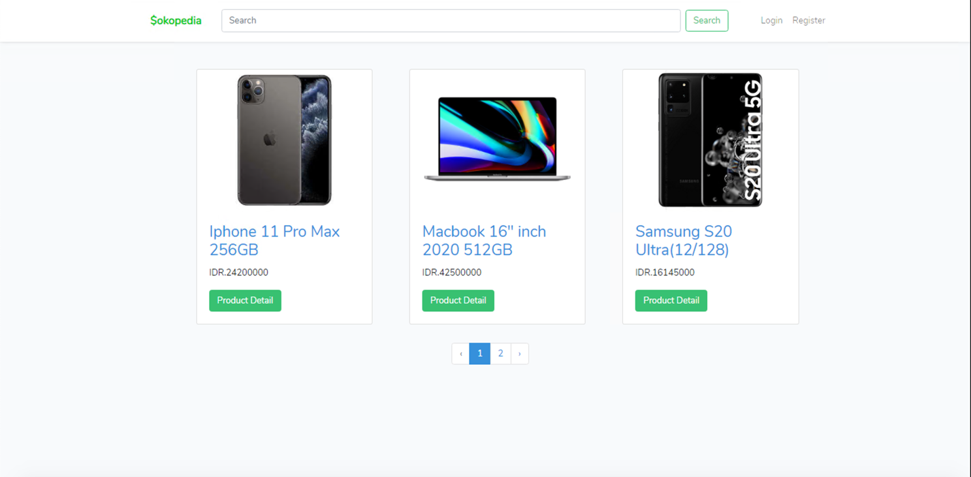

***Figure 3. Home Page (for Member)***

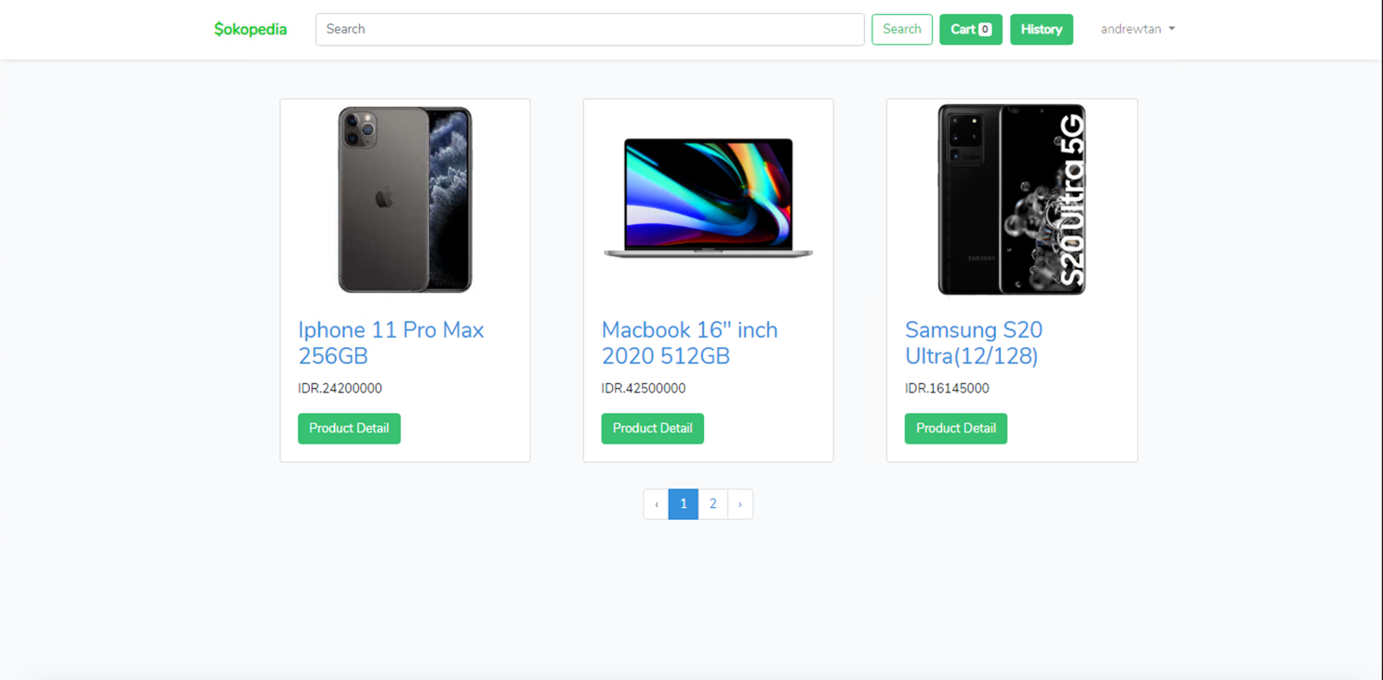

***Figure 4. Home Page (for Guest)***

1. **View Product’s Detail**

This page is accessible for **member only**. If guest trying to access this page, they will be redirected to **Login Page** before access **Product Detail Page**. This page shows product’s detail based on product clicked. This page is also **included with a search field**, so you can search $okopedia’s products **by Product’s Name**. **This page displays Product’s image, name, price, and description.**

In this page, there is **add to cart button** that can be clicked and redirect to “**add to cart page”**

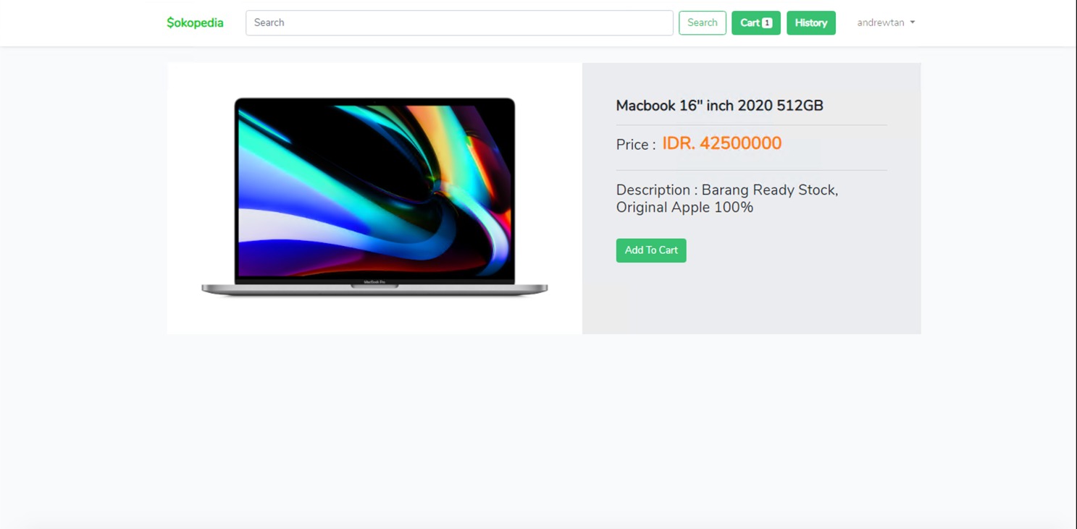

***Figure 5. Product’s Detail Page (for Member)***

1. **Add to Cart Page**

This page is accessible for **member only**. In this page, member can input **quantity** of product they want to add into cart and click **add to cart** **button**. Then, the product will be added to the cart and the cart counter will update. If members add a product that existed inside the cart, the quantity of the product in the cart will **change** **into the newest quantity inputted**.

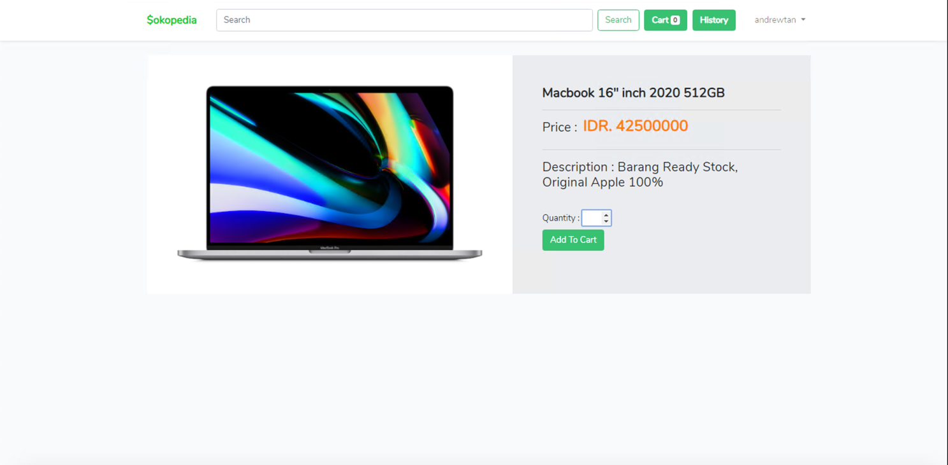

***Figure 6. Add to Cart Page***

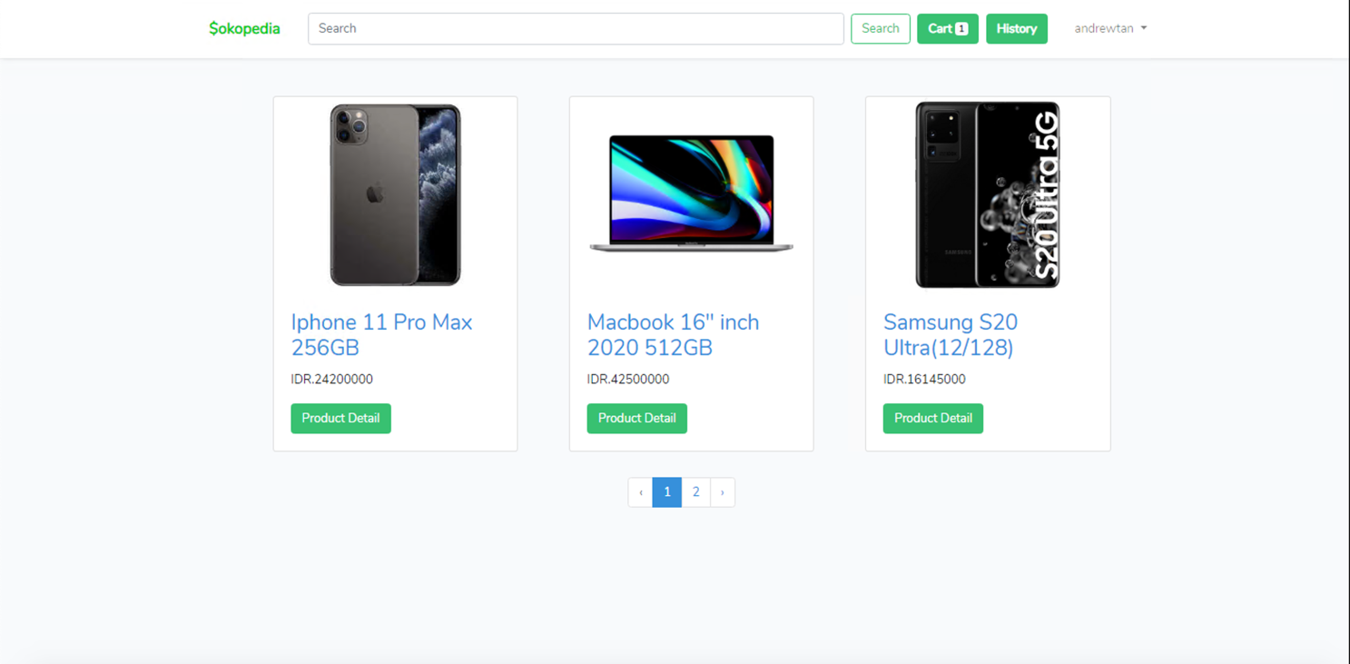

***Figure 7. After Add to Cart***

1. **Cart List Page**

This page is accessible for **member only**. This page displays all product that added to cart, and including their **image**, **name**, **total price**, **quantity**. In this page, member can **delete** or **edit** **quantity** of their product in the cart or **Checkout** the cart, **validate** that Checkout button shown only when **cart not empty**. If member clicked **checkout** button, it would **clear** the cart, and **add** a new **transaction** in the **“History Page”.**

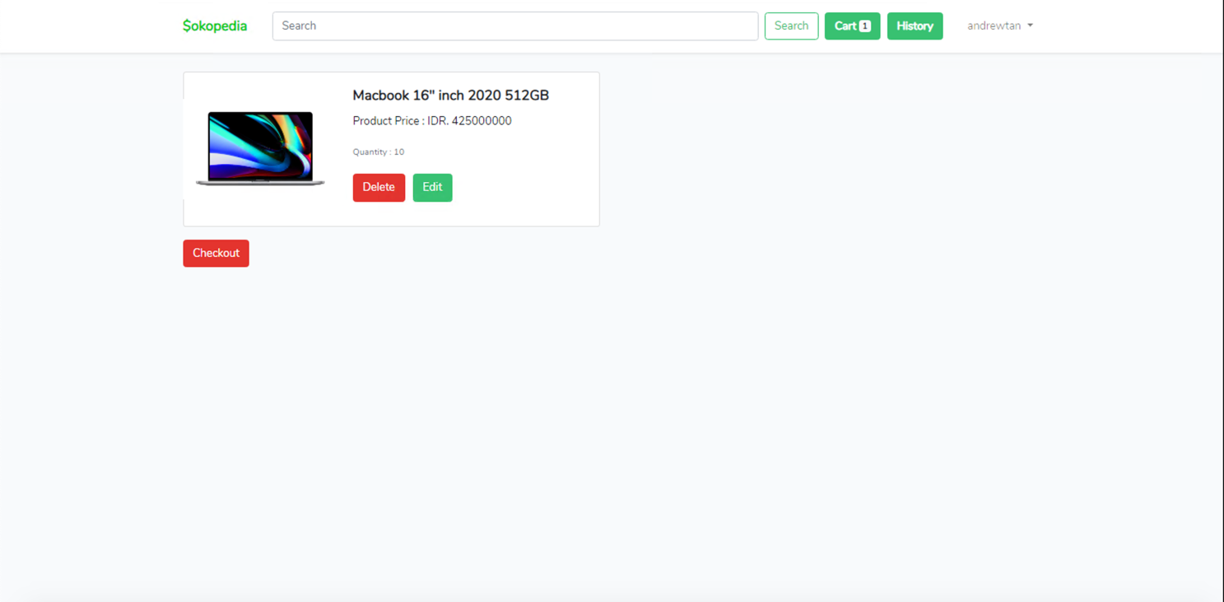

***Figure 8. Cart List Page***

1. **History Page**

History page can be access by clicking **history** button beside cart, and only accessible for member. This page **displays all transaction date of current logged member**. Every transaction can be clicked and redirect to **“Detail Transaction Page”**

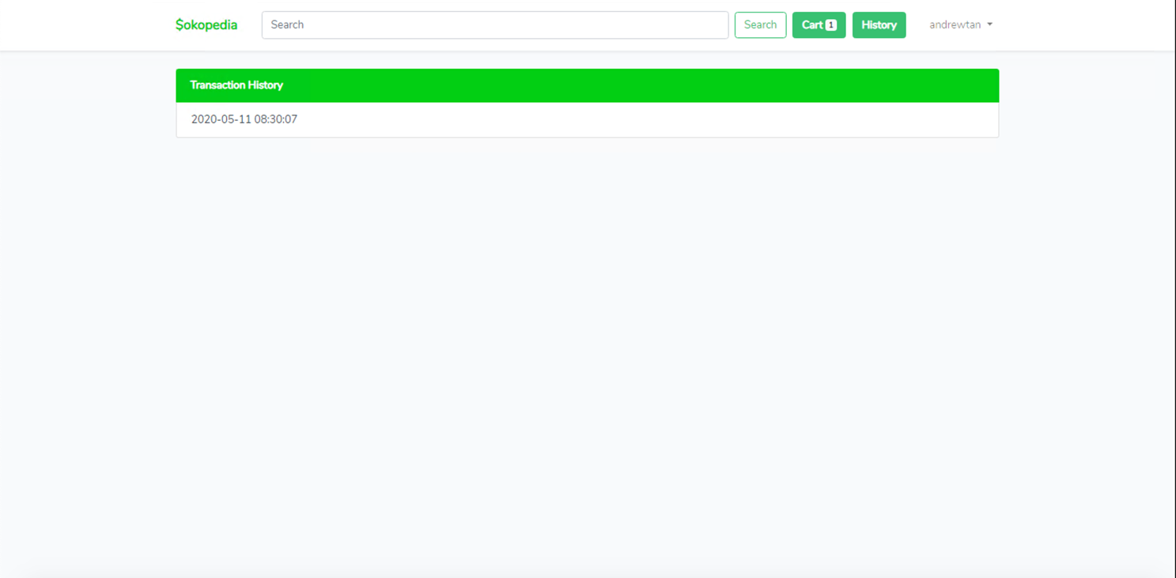

***Figure 9. History Page***

1. **Detail Transaction Page**

Detail transaction page displays all product bought in a transaction selected from History page. Every transaction detail must display **product** **image, name, total price, and quantity.**

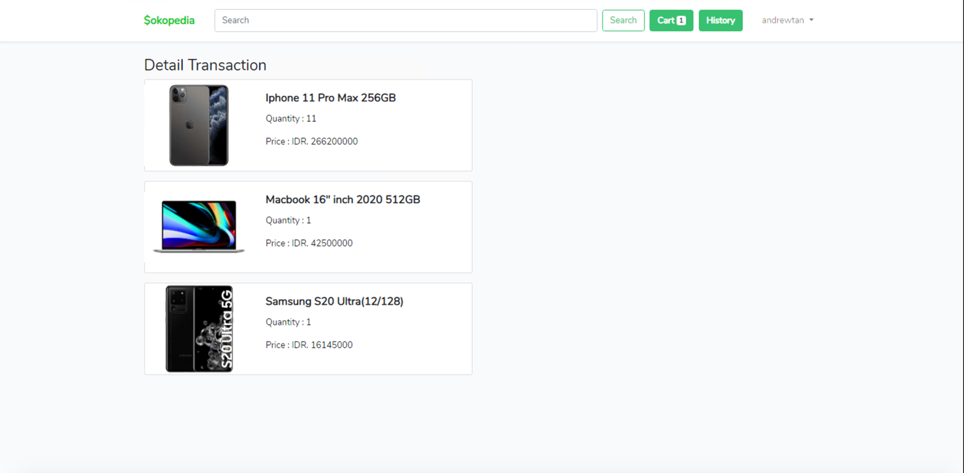

***Figure 10. Detail Transaction Page***

1. **Admin Panel**

This page only accessible by Admin. In this page admin can **add product**, **show all product**, **add category,** and **show all category.**

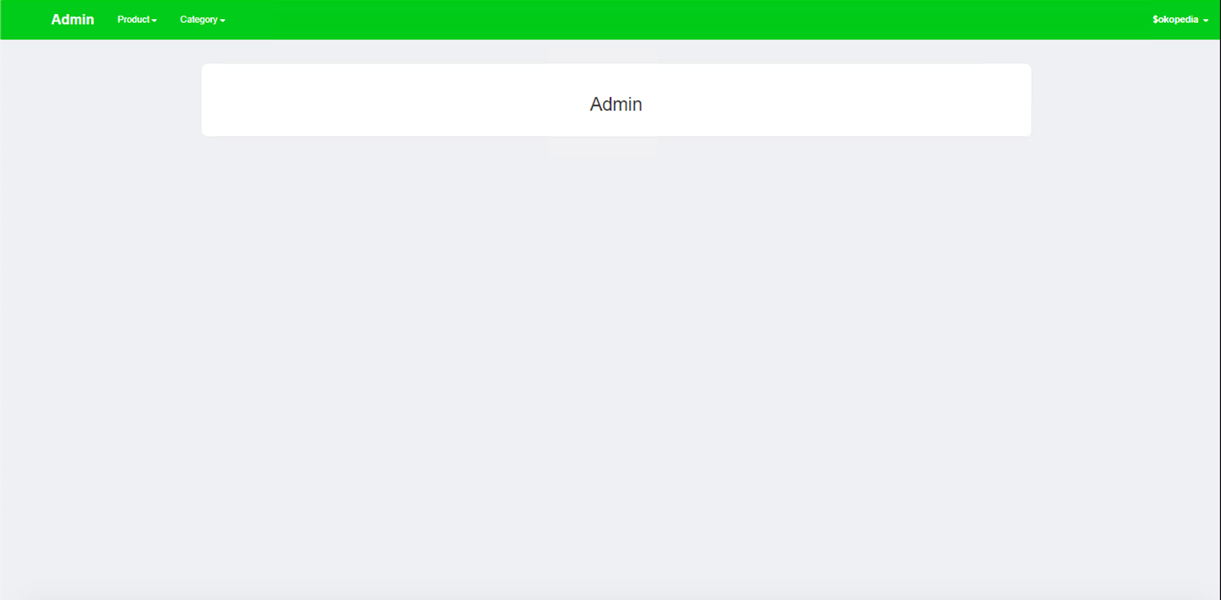

***Figure 11. Admin Panel Page***

1. **Add Product**

This page is only accessible for Admin. In this page, Admin can **add** new product. This page can be access when **Admin** choose “Add Product” Button.

The following table shows existing fields in the page and the validation for each field:

|  |  |
| --- | --- |
| **Field** | **Information** |
| **Name** | Must be **filled** and must be **unique** |
| **Category** | Must be **selected** |
| **Description** | Must be **filled** |
| **Price** | Must be **filled** and **minimal** **100** |
| **Image** | Must be **filled,** must be **image** and **maximum size 10000KB** |

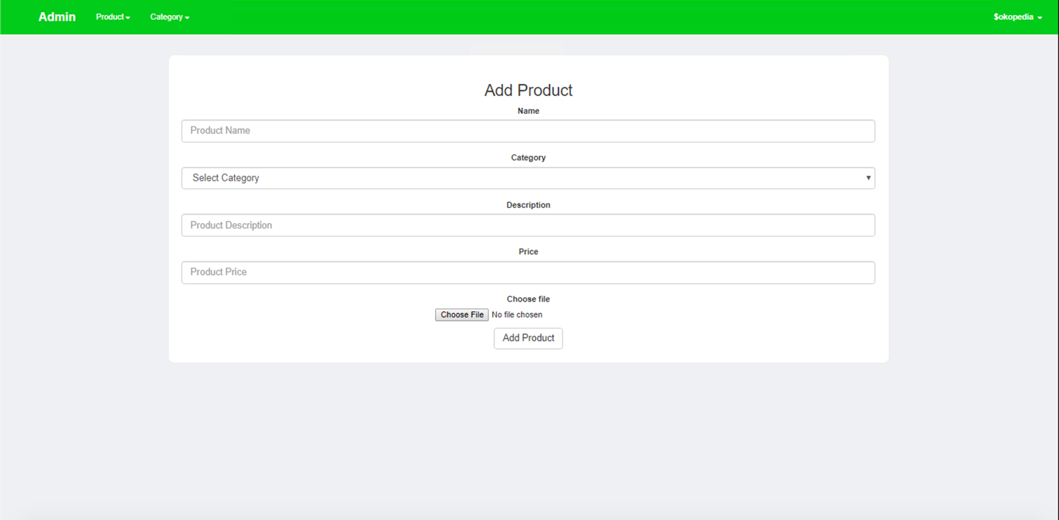

***Figure 12. Add Product Page***

1. **List Product Page**

This page allows Admin to see all products. This page can be access when **Admin** choose “List Product” Button. There is also a “**Delete**” button in each product to delete the product. This page displays all product **image, name, price, description.**

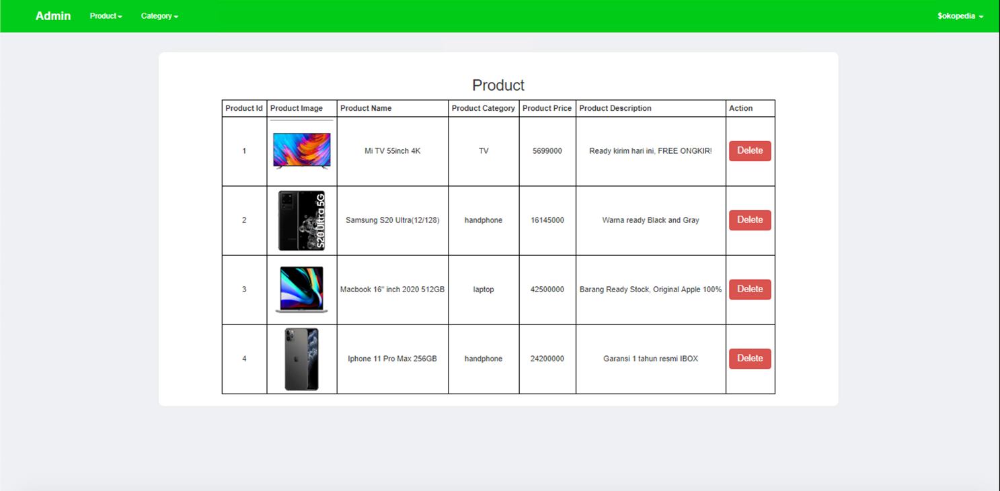

***Figure 13. List Product Page***

1. **Add Category**

This page will allow **Admin** to add new product category, this page can be access when **Admin** choose “Add Category” Button.

The following table shows existing fields in the page and the validation for each field:

|  |  |
| --- | --- |
| **Field** | **Information** |
| **Name** | Must be **filled and unique** |

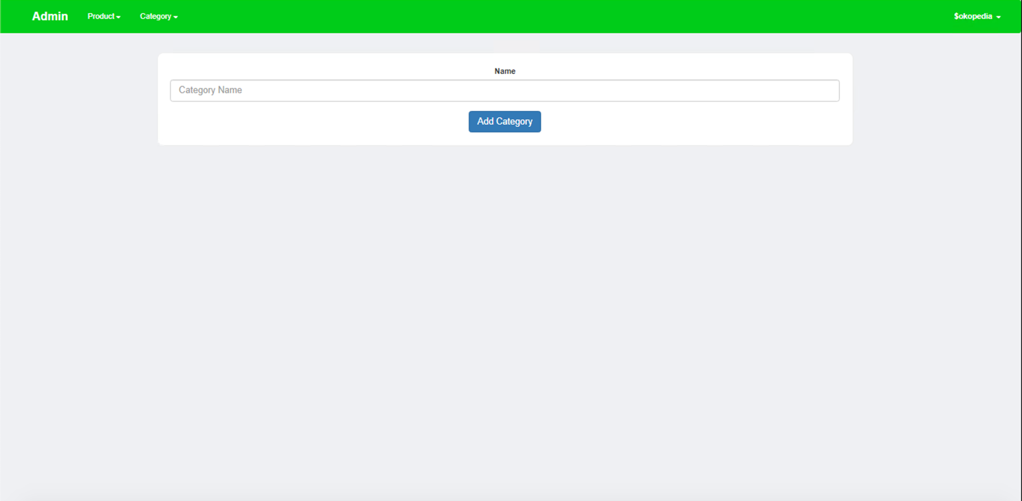

***Figure 14. Add Category Page***

1. **List Category Page**

This page allows **Admin** to view all the product category. And each category can be clicked and show **product** by **category** clicked. Product information that must be displayed are **product id, product image, product name, product price, and product description**.

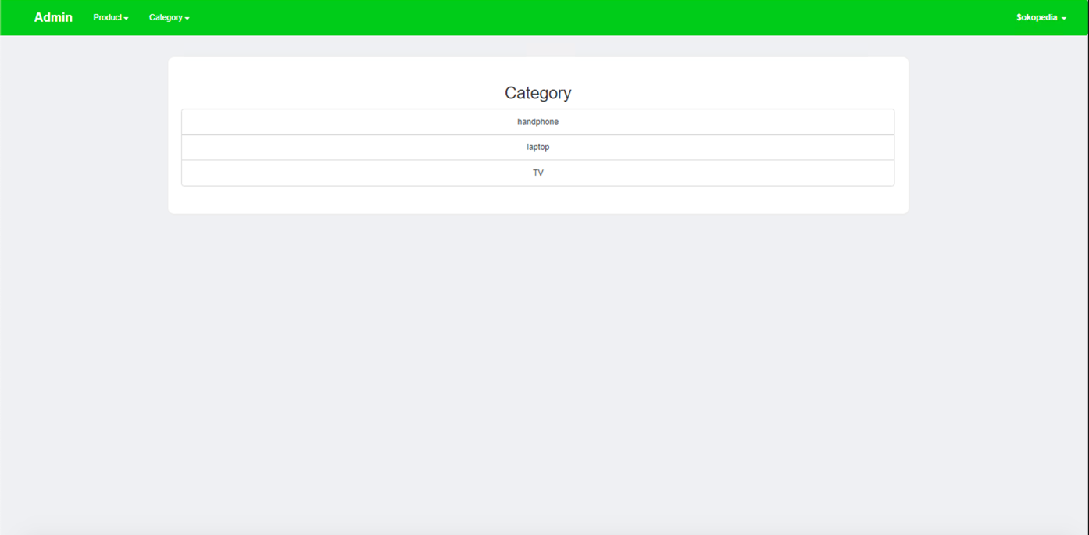

***Figure 15. List Category Page***

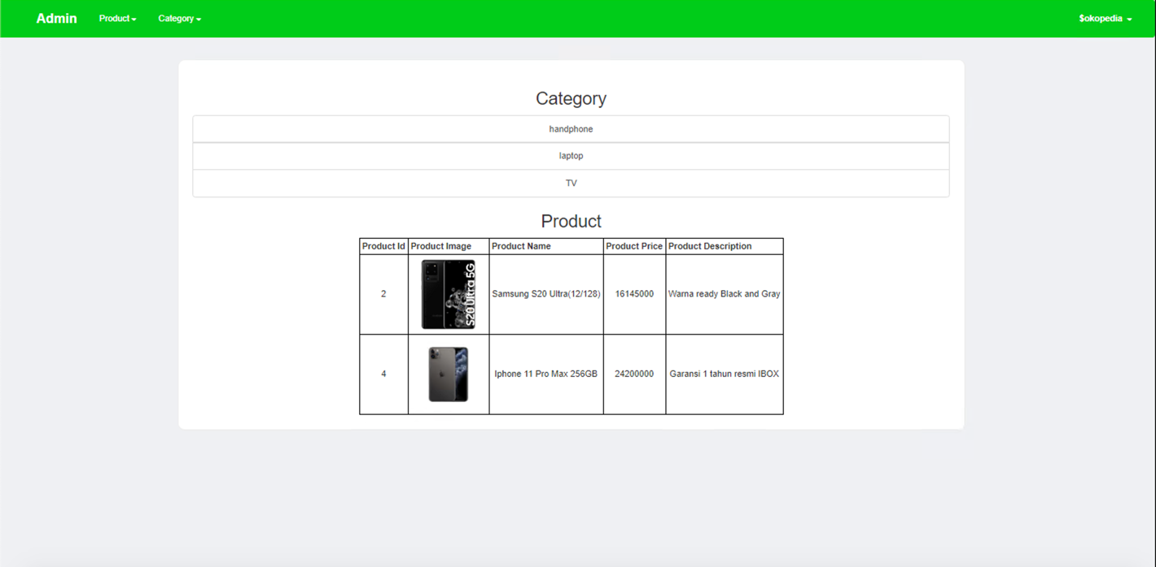

***Figure 16. Handphone Category Clicked***

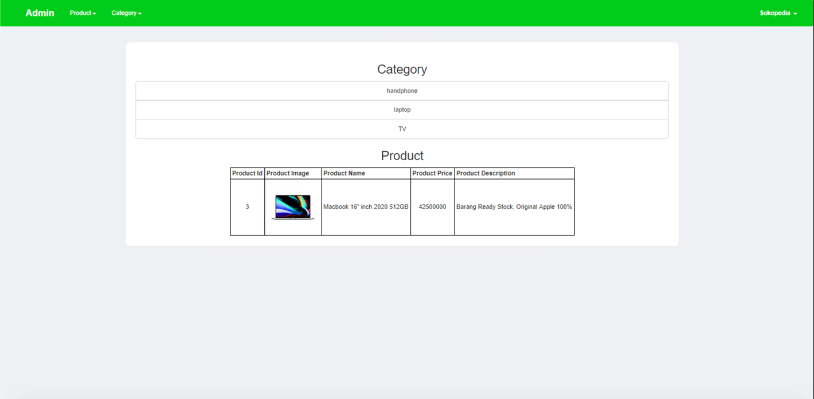

***Figure 17. Laptop Category Clicked***

Here are the rules that you must follow to create your project:

1. Use appropriate software for this subject based on **Sistem Praktikum** that can be downloaded from Binusmaya.
2. Collect appropriate files for this subject based on **Sistem Praktikum** that can be downloaded from Binusmaya.
3. Include the other files that can support your project, such as:
   * All files in your project
   * Other files (image, audio, video, etc.) used in your project
   * *.DOC file (documentation of your project) that contains all pages in your project, reference links of additional files (image, audio, video, etc.) used in your project, the description about how to use your application, etc
4. If there are some hidden creativities, please note them in the existing documentation because they can greatly affect your project score

**References Link:**

<https://www.google.com/url?sa=i&url=https%3A%2F%2Fid.priceprice.com%2FApple-iPhone-11-Pro-Max-29435%2Fspecs%2F&psig=AOvVaw0mqFgZDgcsW4lsGCijObgP&ust=1589345844764000&source=images&cd=vfe&ved=0CAIQjRxqFwoTCIjy5ebErekCFQAAAAAdAAAAABAD>

<https://www.google.com/url?sa=i&url=https%3A%2F%2Fwww.movertix.com%2Fen%2Fsamsung-galaxy-s20-ultra-5g-cosmic-black-128gb-and-12gb-ram-sm-g988b.html&psig=AOvVaw34OXMzUnNd9TGepVP2e8jO&ust=1589345885299000&source=images&cd=vfe&ved=0CAIQjRxqFwoTCODUwvvErekCFQAAAAAdAAAAABAD>

<https://www.google.com/url?sa=i&url=https%3A%2F%2Ftekno.kompas.com%2Fread%2F2020%2F03%2F27%2F11530057%2Fmacbook-pro-16-inci-resmi-dijual-di-indonesia-harga-rp-36-juta&psig=AOvVaw3wt_D24EnUTd5lNMi6m4gD&ust=1589345918668000&source=images&cd=vfe&ved=0CAIQjRxqFwoTCLDhh4_FrekCFQAAAAAdAAAAABAD>

<https://www.google.com/url?sa=i&url=https%3A%2F%2Fshopee.co.id%2FXiaomi-Mi-TV-55-inch-4K-Android-9.0-smart-TV-Mi-55-UHK-SELAIN-BANDUNG-i.94409671.7926408833&psig=AOvVaw1hqt8-6a42NmKf0WPtCg_p&ust=1589345961461000&source=images&cd=vfe&ved=0CAIQjRxqFwoTCIj9453FrekCFQAAAAAdAAAAABAD>